Stakeholder Engagement Levels

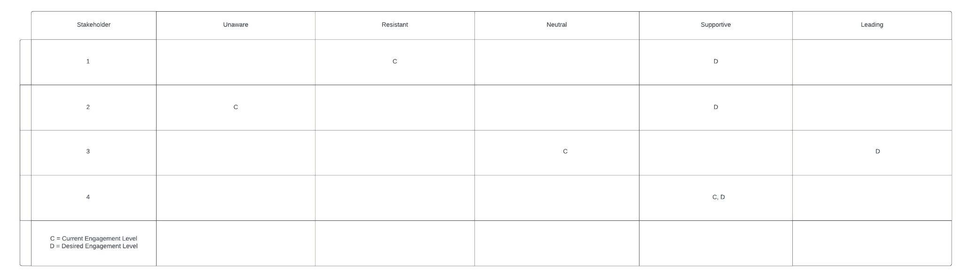

Stakeholder 1 is currently resistant to the project but we want them to be supportive. They are being resistant due to potential unknown costs with the blockchain project. Neutral could be better but we really need to get all stakeholders onboard with our blockchain project. Perhaps they have been misinformed and we can talk over the details again, in order to try and move stakeholder 1 from resistant to supportive.

Stakeholder 2 is currently unaware of the new blockchain project. Therefore, we need to inform the stakeholder of the new project and explain the details. Explaining the detail and how it will help the company ought to make stakeholder 2 move from the unaware status to the desired supportive status. Unless the stakeholder is out of the office we need to contact them immediately and inform them of the new blockchain project.

Stakeholder 3 is currently neutral towards the project but we are hoping to put the stakeholder into the leading status. This stakeholder has a lot of experience and connections in the blockchain world and would be highly beneficial to the project. We need to go over any misinformation the stakeholder may have heard. Even though the stakeholder is not negative towards the project, their background would make it highly positive if they were in the leading status.

Stakeholder 4 is currently supportive and is desired to be supportive. This is the goal of where stakeholders should be. The current and the desired engagement levels always strive to be in the same status. Not much is needed to be done with this stakeholder. We simply need to make sure they remain at their current engagement level.